Cloudwatch

To view the output of your project, Go to Cloudwatch, and create a dashboard called “sentiment-dashboard”. Add Line Widget:

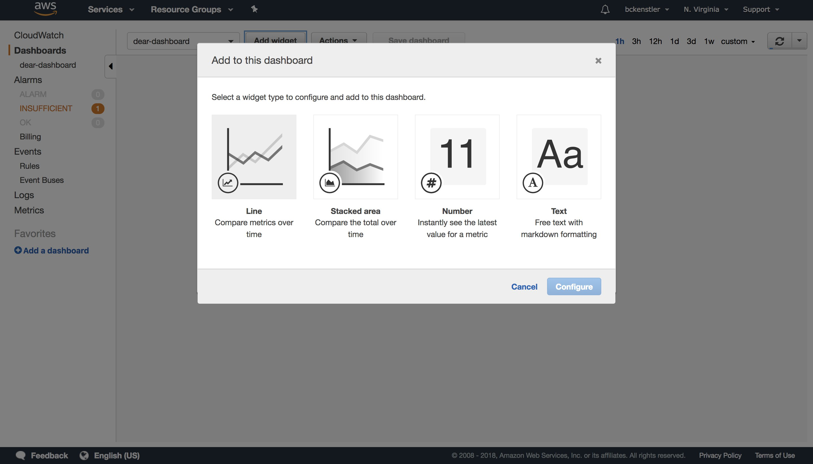

Under Custom Namespaces, select “string”, “Metrics with no dimensions”, and then select all metrics:

**NOTE:** These metrics will only appear once they have been sent to Cloudwatch via the Rekognition Lambda. It may take some time for them to appear after your model is deployed and running locally. It they **do not** appear, then there is a problem somewhere in the pipeline.

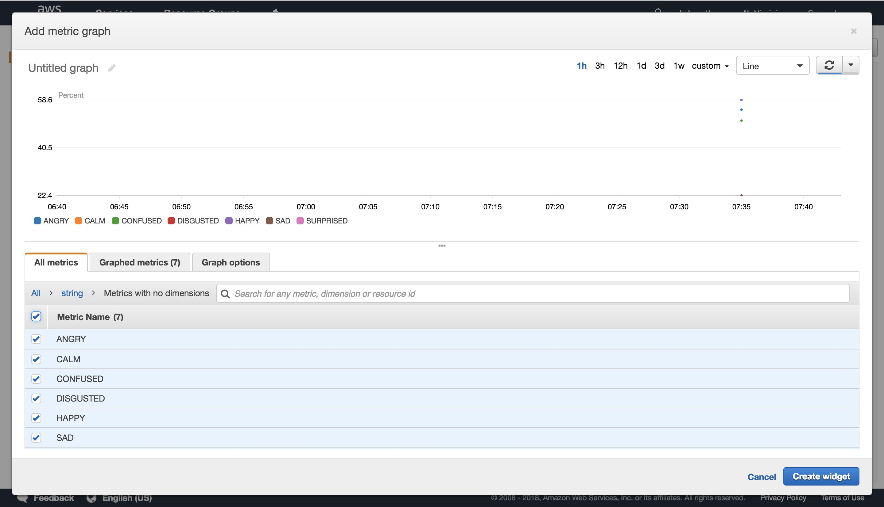

Next, set “Auto-refresh” to the smallest interval possible, and change the “Period” to whatever works best for you.

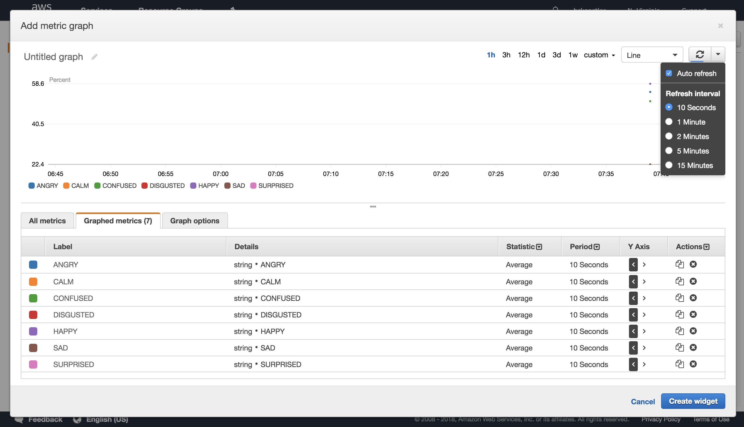

As the metrics start coming in, you'll see lines being drawn.